Home learning week 3
Communication and Language Activities
Share and discuss the story. What is happening in the story? Why does the caterpillar get fat? How does he turn into a butterfly? Think of different ways to retell the story for example using a homemade caterpillar (there are lots of ideas how to do this below) and play food. Learn and act out the song: There’s a Tiny Caterpillar on a Leaf.
The Tiny Caterpillar Song can be found here: https://youtu.be/JOlbSE0CmNM
Physical Activities
Think of lots of actions to help act out the tiny caterpillar song for example crawling, munching (make actions with hands), spinning and flapping. Which other mini-beasts can the children think of and how do they move? Try some caterpillar themed activities (hole-punching, threading, cutting, etc) that will help to keep those little fingers busy and help finger muscles grow strong. There are a couple of ideas below:
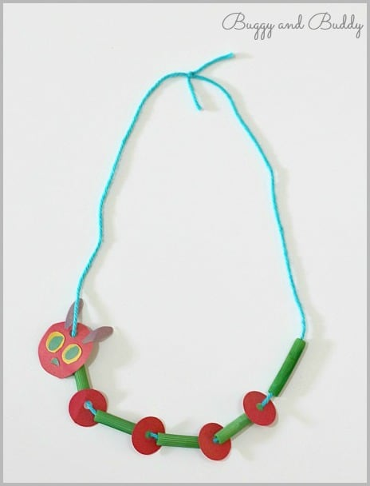
Personal, Social and Emotional Activities
What living things do you have at home that need looking after and what do they need? For example, do you need to water the plants or feed your pets? If you don’t have any plants or pets maybe you can find some living creatures in the garden? Teach your child to care for living things for example to put a ladybird back on a leaf or a woodlouse back under the rock where it came from. How might that small creature feel if taken from its home?
Literacy
Have some fun making caterpillar themed letters for example finger painting or sticking circle shapes. Show the children how to make a curly C for caterpillar. Experiment with making other initial sounds for example M for Mummy, S for sister and the sound at the beginning of your child’s name.
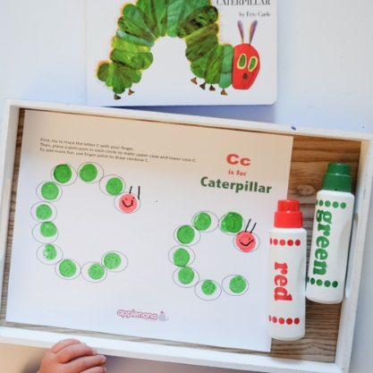
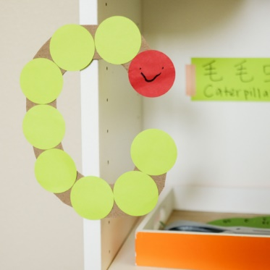

Maths
You will be able to find lots of opportunities to talk about mathematics in the Hungry Caterpillar story. For example, talk about the days of the week, how many different fruits there are and also the size of the caterpillar. Why not try making different sized caterpillars with whatever resources you can find? (Paper plates, plastic bowls, stickers, buttons, pasta, paint etc)
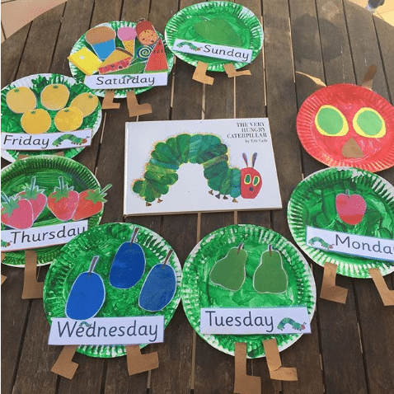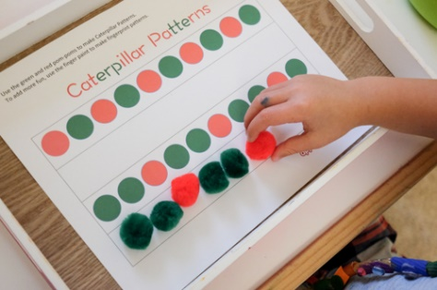

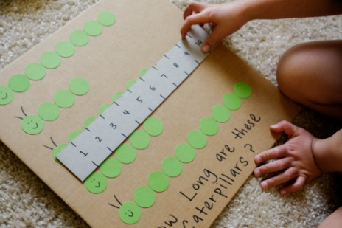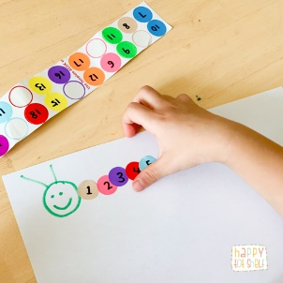

Creative
Have a look at some of the ideas below or think of some of your own. We can’t wait to see your creative caterpillars and brilliant butterflies!
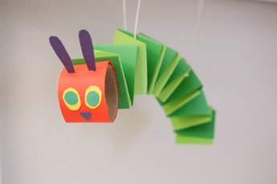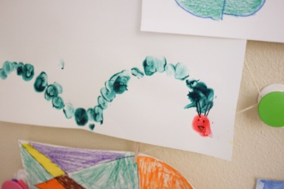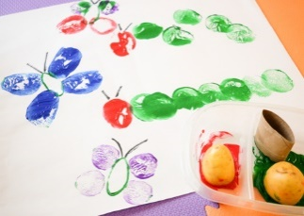
Knowledge and Understanding of the World
When talking about the caterpillar story the children will be learning about growth and change. This caterpillar activity would make a lovely keepsake memory for you to share with your child in the future. Why not add a photo or ask your child to draw a picture of themselves then write down all their favourite things? It will be fun to look back on in the future. Especially if you are keeping all your Covid 19 lockdown memories in a safe place.

These lovely activity ideas and many more can be find at the following websites:
https://www.weareteachers.com/very-hungry-caterpillar-activities/
https://happytotshelf.com/hungry-caterpillar-learning-shelf-activities/

Remember to have lots of fun and send us your pictures on class Dojo!

