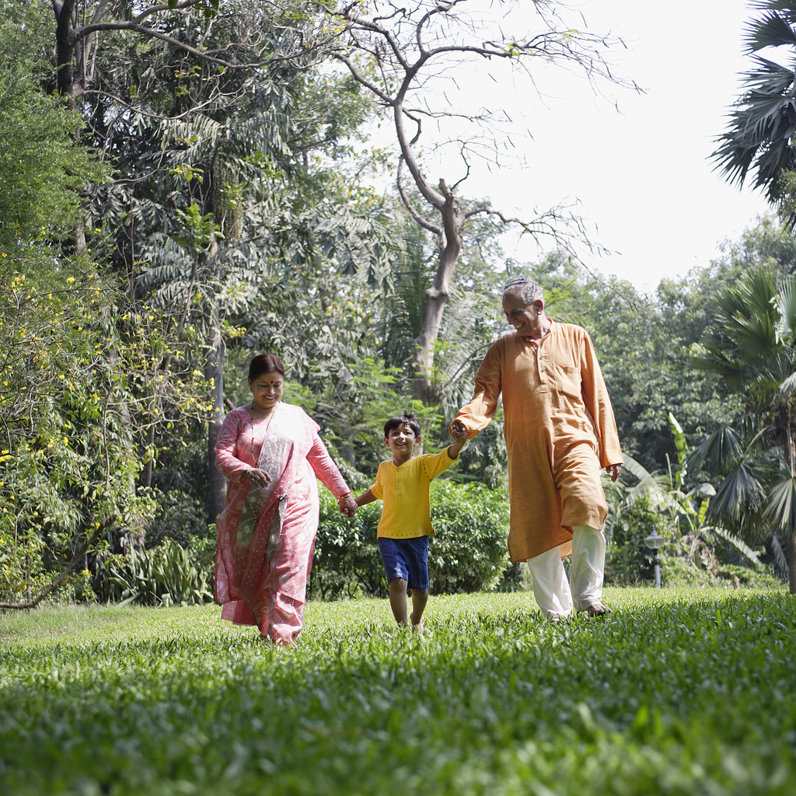

**Talk to Me**

**Going for a walk**

Help your child to learn new words.

Take your child to the park or anywhere outdoors.

Use every opportunity to talk to your child and help to learn about the world around them.

Give your child lots of praise and encouragement.