St Mary Magdalene

Church, Creswell

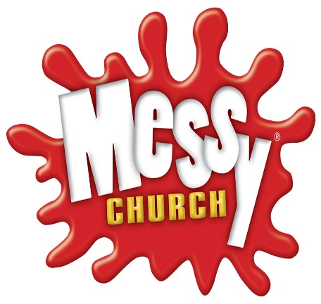

Messy Church Harvest!

Invite you to

Fun for

all the family

**Saturday 29th October 10.30am–12.00noon**

Craft / Worship / Food

having fun and sharing God's love!

All Welcome!