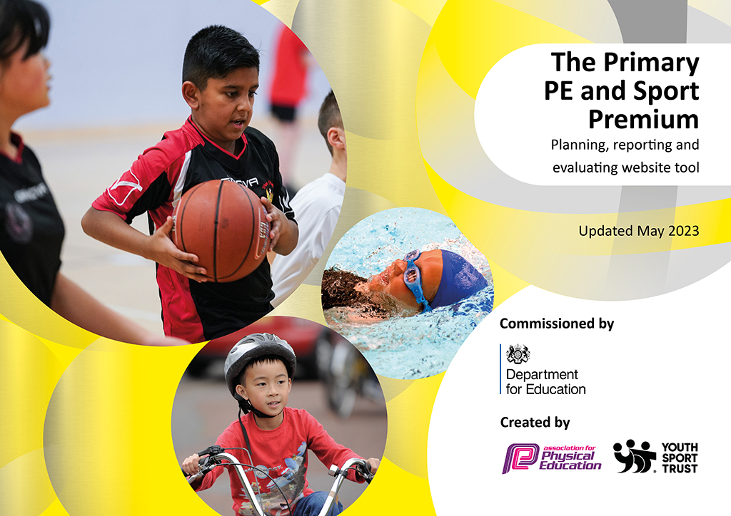
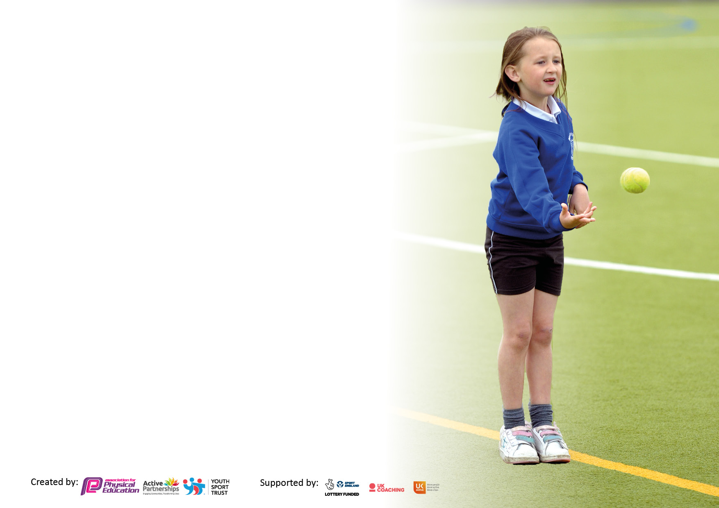

It is important that your grant is used effectively and based on school need. The Education Inspection Framework makes clear there will be a focus on ‘whether leaders and those responsible for governors all understand their respective roles and perform these in a way that enhances the effectiveness of the school’.

Under the Quality of Education Ofsted inspectors consider:
Intent - Curriculum design, coverage and appropriateness
Implementation - Curriculum delivery, Teaching (pedagogy) and Assessment
Impact - Attainment and progress

To assist schools with common transferable language this template has been developed to utilise the same three headings which should make your plans easily transferable between working documents.

Schools must use the funding to make additional and sustainable improvements to the quality of Physical Education, School Sport and Physical Activity (PESSPA) they offer. This means that you should use the Primary PE and sport premium to:

- Develop or add to the PESSPA activities that your school already offer
- Build capacity and capability within the school to ensure that improvements made now will benefit pupils joining the school in future years
- The Primary PE and sport premium should not be used to fund capital spend projects; the school’s budget should fund these.

Please visit gov.uk for the revised DfE guidance including the5keyindicatorsacrosswhichschoolsshoulddemonstrate an improvement. This document will helpyoutoreviewyourprovisionandtoreportyourspend.DfEencouragesschools to use this template as an effective way of meeting the reporting requirements of the Primary PE and Sport Premium.

We recommend you start by reflecting on the impact of current provision and reviewing the previous spend.

Schools are required to publish details of how they spend this funding, including any under-spend from 2021/2022, as well as on the impact it has on pupils’ PE and sport participation and attainment. The funding should be spent by 31st July but the DfE has stated that there will be no clawback of any unspent money so this can be carried forward into 2023/24.

We recommend regularly updating the table and publishing it on your website throughout the year. This evidences your ongoing self-evaluation of how you are using the funding to secure maximum, sustainable impact. Final copy must be posted on your website by the end of the academic year and no later than the 31st July 2023. To see an example of how to complete the table please click HERE.

Details with regard to funding
Please complete the table below.

Total amount carried over from 2021/22 | £12,672
Total amount allocated for 2021/22 | £17,721 = £29,943
How much (if any) do you intend to carry over from this total fund into 2022/23? | £7006.50
Total amount allocated for 2022/23 | £17,063
Total amount of funding for 2022/23. Ideally should be spent and reported on by 31st July 2023. | £ 24,069
Swimming Data
Please report on your Swimming Data below.

Meeting national curriculum requirements for swimming and water safety.  N.B. Complete this section to your best ability. For example you might have practised safe self-rescue techniques on dry land which you can then transfer to the pool when school swimming restarts.  Due to exceptional circumstances priority should be given to ensuring that pupils can perform safe self rescue even if they do not fully meet the first two requirements of the NC programme of study | N/A
What percentage of your current Year 6 cohort swim competently, confidently and proficiently over a distance of at least 25 metres?  N.B. Even though your pupils may swim in another year please report on their attainment on leaving primary school at the end of the summer term 2023.  Please see note above | N/A
What percentage of your current Year 6 cohort use a range of strokes effectively [for example, front crawl, backstroke and breaststroke]?  Please see note above | N/A
What percentage of your current Year 6 cohort perform safe self-rescue in different water-based situations? | N/A
Schools can choose to use the Primary PE and sport premium to provide additional provision for swimming but this must be for activity over and above the national curriculum requirements. Have you used it in this way? | N/A

Action Plan and Budget Tracking
Capture your intended annual spend against the 5 key indicators. Clarify the success criteria and evidence of impact that you intend to measure to evaluate for pupils today and for the future.

Academic Year: 2022/23 | Total fund allocated: | Date Updated:
Key indicator 1: The engagement of all pupils in regular physical activity – Chief Medical Officers guidelines recommend that primary school pupils undertake at least 30 minutes of physical activity a day in school |  |  |  | Percentage of total allocation:
 |  |  |  | %
Intent | Implementation |  | Impact
Your school focus should be clear what you want the pupils to know and be able to do and about  what they need to learn and to  consolidate through practice: | Make sure your actions to achieve are linked to your intentions: | Funding allocated: | Evidence of impact: what do pupils now know and what can they now do? What has changed?: | Sustainability and suggested next steps:
Give the children a rich cross-curricular approach to P.E that will set them up and prepare them for their future life.  Ensure this approach also incorporates a mindful approach that looks at social and emotional health.  All pupils to make progress in each lesson/cog/year.  Development of their fundamental skills and movement to help develop fine and gross motor skills.  Children to have the opportunity to try a range of different sports and become more active. Children will be able to develop new skills and have links to local sports clubs.  To ensure that children are physically active and engage in at least 30 minutes physical activity a day. | Real P.E  P.E and social and emotional health course for the PE lead.  P.E resource audit and new PE Equipment bought providing a range of good Quality PE equipment.  Fundamental interventions  -Bolsover interventions  -Samba lunchtime club.  Promote and encourage children to take part in after school clubs and local sports clubs by promoting it on class Dojo and on leaflets.  Stationary sports equipment for the playground so this can be accessed at break and lunchtimes. | £695  £125  Resources  £917  Included with Bolsover SSP (£5717)  £25  £6571 | P.E equipment audit – Staff to have the correct and enough equipment to teach a broad and balanced curriculum.  P.E lead to upskill all staff so that they have a good understanding of social and emotional health.  Whole school assessment tool to show above and below in P.E and Eazmag to show above and below in Early years.  Evidence shown in P.E lessons and in children’s writing, teacher feedback and learning walks.  Evidence shown in after school club registers. More children are taking part in after school clubs.  Parents are aware of these clubs from letters, text messages and class dojo messages.  To continue to develop their gross motor skills independently at break times. | All children will access two hours of high quality PE, using high quality PE equipment.  P.E lead to do a staff meeting on social and emotional health in P.E and to support staff in lessons.  To ensure all staff are confident in using the Real PE assessment tool.  Fine and gross motor activities are embedded throughout the school in a cross curricular approach.  Next step – To continue to develop more active lunch and playtimes through structured play.  To continue to improve the playground and ensure high quality equipment is accessible to all.
Key indicator 2: The profile of PESSPA being raised across the school as a tool for whole school improvement |  |  |  | Percentage of total allocation:
 |  |  |  | %
Intent | Implementation |  | Impact
Your school focus should be clear what you want the pupils to know and be able to do and about  what they need to learn and to  consolidate through practice: | Make sure your actions to achieve are linked to your intentions: | Funding allocated: | Evidence of impact: what do pupils now know and what can they now do? What has changed?: | Sustainability and suggested next steps:
Make sure children are engaged in physical activities at break and lunch time.  PE and Sport achievements are mentioned in class/celebration assembly to ensure the whole school are aware of how important it is. This will also encourage other less active pupils to become involved in order to be mentioned in assemblies.  Children will develop their leadership skills.  Children to stay active as much as they can throughout the school day. | New high quality P.E equipment.  Assemblies to celebrate our achievements.  We will train the Year 2’s to become mini leaders for Foundation and year 1 during lunch times.  Whole school approach to the daily mile.  Cosmic yoga  Kidsbop  Supermovers  Go Noodle | Equipment as above.  £25 resources  No costs | Children are active and enjoy sport. This gives them a positive mind set for sport and will hopefully encourage them to continue sport throughout life.  P.E display board in the hall- That show’s children/s achievements to give them a sense of pride.  The display board also shows Real PE objectives so children know how to challenge themselves and become interested in their learning.  The children have opportunities to be leaders and to organise games and events (Such as sports day and team building days). They will have a pupil’s voice and will listen to what their peers want.  Children will be more active throughout the day. I will know this through lesson observations and from staff and pupil feedback. | To promote sporting achievements in assemblies.  Continue to develop lunchtime activities.  Continue to develop more active lessons through a cross curricular approach and through High quality teaching.

Key indicator 3: Increased confidence, knowledge and skills of all staff in teaching PE and sport |  |  |  | Percentage of total allocation:
 |  |  |  | %
Intent | Implementation |  | Impact
Your school focus should be clear | Make sure your actions to | Funding | Evidence of impact: what do | Sustainability and suggested
what you want the pupils to know | achieve are linked to your | allocated: | pupils now know and what | next steps:
and be able to do and about | intentions: |  | can they now do? What has
what they need to learn and to |  |  | changed?:
consolidate through practice:
Continue to develop the teachers skills and knowledge of a range of sports. This will give the children High quality PE lessons. | Book specialist PE coaches to work alongside staff and train and upskill them in different areas of P.E. | Specialist sports teacher part of Bolsover SPP.  £5717  Dance with Laura Ann  £2765  Samba  £3980  Basketball  £400  Real PE subscription as above. | Staff feel confident teaching and assessing PE. They know the progression of skills throughout FS and KS1. They teach the children the skills to be able to challenge themselves aswell as having the support and guidance from the teacher. Staff teach the children to practise but they also allow the children to make their own mistakes and learn from these. | Staff will continue to use Real PE to keep their knowledge ongoing and to ensure the progression of skills is consistent throughout school.  Next Step – To continue to develop and assess staff weakeness and strengths within P.E  To audit staff to identify their Weaknesses and to give them support in this area.
Key indicator 4: Broader experience of a range of sports and activities offered to all pupils |  |  |  | Percentage of total allocation:
Intent | Implementation |  | Impact
Your school focus should be clear | Make sure your actions to | Funding | Evidence of impact: what do | Sustainability and suggested
what you want the pupils to know | achieve are linked to your | allocated: | pupils now know and what | next steps:
and be able to do and about | intentions: |  | can they now do? What has
what they need to learn and to |  |  | changed?:
consolidate through practice:
Additional achievements:  To ensure a range of sports and activities are offered to all pupils through festivals, team building days and competitions.  Children will have the opportunities to try new sports in after school clubs. | Affiliate to SSP to access a broad range of festivals. Intra school sports competitions arranged within school.  Assembly and newsletter to promote after school clubs and sporting events.  Arrange and book a range of sporting after school clubs.  Promote after school clubs and encourage children to attend them through class Dojo, assemblies and news letters. | £1540  After school clubs above. | The children have the opportunity to compete against other children from other schools and to learn a range of skills.  Club registers – The children will have the opportunities to experience a range of sporting activities afterschool. | Next steps – To increase pupils attending competitions and festivals and push gifted and talented to attend also.  Next steps – To continue to develop a range of after school clubs to increase uptake in the clubs.  Continue to develop local club links.  Introduce – Orienteering/ Boccia/Soft Archery into the school timetable.

Key indicator 5: Increased participation in competitive sport |  |  |  | Percentage of total allocation:
 |  |  |  | %
Intent | Implementation |  | Impact
Your school focus should be clear | Make sure your actions to | Funding | Evidence of impact: what do | Sustainability and suggested
what you want the pupils to know | achieve are linked to your | allocated: | pupils now know and what | next steps:
and be able to do and about | intentions: |  | can they now do? What has
what they need to learn and to |  |  | changed?:
consolidate through practice:
Children will be able to develop skills in competitive sports.  Children are motivated, engaged and physical during lunchtimes and play.  Children to support eachother in working together to progress and improve their P.E skills. They can work well together and as a team.  Children will enjoy success and enjoy being part of a team.  Children have the opportunites to compete against different schools and within school. | Ensure that competitive sports and competitions are planned into the school calendar.  Plan and organise a sports week.  Plan a team building competitive day.  Train year 2 to become mini leaders.  Book a variety of sporting after school clubs.  Take children to a range of PE festivals and competitions.  Work with Midday staff to plan lunchtime events.  P.E lead to attend meetings within the cluster. Events will be organised with local schools. | Infant package as above.  (£1540) | Meetings with Midday staff to plan and organise lunchtime events.  Meetings with play leaders to train and plan – This will develop leadership skills.  Register/Photographs – The children are given the opportunities to compete against other children from a range of schools in the cluster and within school. These are great experiences. | All children to take part in intra activities and competition events.  Continue to plan activities to develop children’s team building – SSP.  Next steps – Begin to embed weekly challenges, both personal and class challenges into the timetable.

Signed off by
Head Teacher: | A DODD
Date: | 20/07/2023
Subject Leader: | B WOODS
Date: | 20/07/23
Governor: | S WILMOT
Date: | 20/07/23

