Creswell Breakfast Club
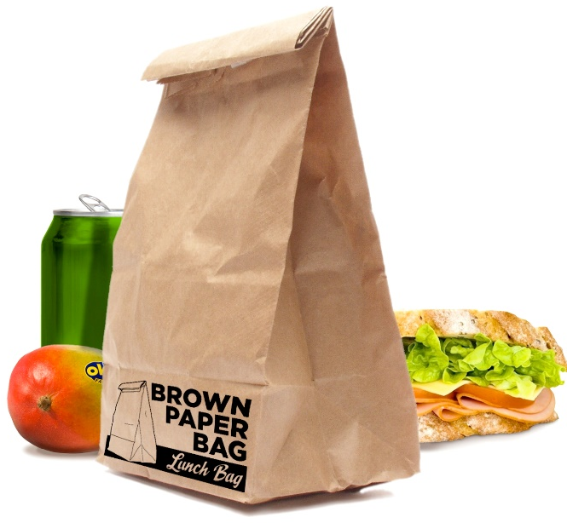
Take away
@
St. Mary Magdalene Church, Creswell

Monday October 24th
Wednesday October 26th
Friday October 28th

10.00am to 11.30am
Come and collect a packed lunch
for only 50p!

EVERYONE WELCOME!

