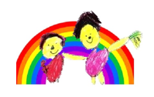
Creswell C.E Infant and Nursery School

Foundation Curriculum letter Spring 1 2019

This term we are learning about Traditional Fairy Tales in Foundation 1 and 2
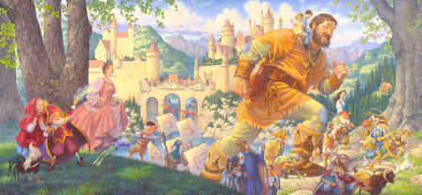

Reading and Writing
We will be reading traditional fairy tales e.g. Goldilocks and the three bears, Little Red Hen, The Gingerbread man, The Three Billy Goats Gruff, Little Red Riding Hood.
We are learning to hear and say the initial sounds in words.
We are learning to continue a rhyming string.
We are learning to use some clearly identifiable letters to communicate meaning, representing some sounds correctly and in sequence.
We are learning to link sounds to letters, naming and sounding the alphabet.
We will be learning to express ourselves by drawing and writing.
We are learning to predict what the story might be about just by looking at the cover.
We are learning to sequence a story in the order that it happens.

We also aim to change reading books weekly, and listen to word boxes changing tricky words and high frequency words each week once the children can read them consistently and confidently.

Communication and Language
We are learning to use words and phrases to explain what we mean.
We are learning to listen to different stories and then ask questions about them?
We are learning to talk about what happens in a story.
We will be learning to talk about what we are writing.
We will be taking part in different role-play activities. We are learning new words.

Mathematics
We will be learning about different 2D and 3D shapes and their properties.
We will learn to identify and match different shapes
We will be going on a shape hunt around our school to find different shapes.
We are learning to order two or three items by length.
We will be learning how to order two items by weight and capacity.
We will use everyday language related to time, e.g Days of the week, months of the year.
We are learning to count objects to 10 and beginning to count beyond.
We are learning to estimate how many objects we can see and check by counting them.

Expressive Arts and Designs
We will be acting out lots of different fairy tales. We will learn new songs related to our stories.
We will be learning to use expressions and different tones when singing.

Understanding of the World
We will be learning about the world around us.
We will be learning about the different characters in our stories.
We will be making and tasting some of the special foods from our traditional fairy tales.

Physical Development
We will be learning to use our bodies with the music and create different dances.
We will be playing parachute games.
We will use ribbons to create large shoulder movements.
We will be travelling with confidence with confidence and skill around, over, under and through balancing equipment.
We are learning to begin to form recognisable letters.
We are learning to jump off an object and land safely.

Personal, Social and Emotional Development
We are learning to share with other children.
We are learning to sit in a circle and talk when we have teddy in our hands.
We are learning to put our hands up if we want to say something.
We are learning to talk about our feelings.
We are learning to look after our classroom and ourselves.
We are learning to look after each other.

