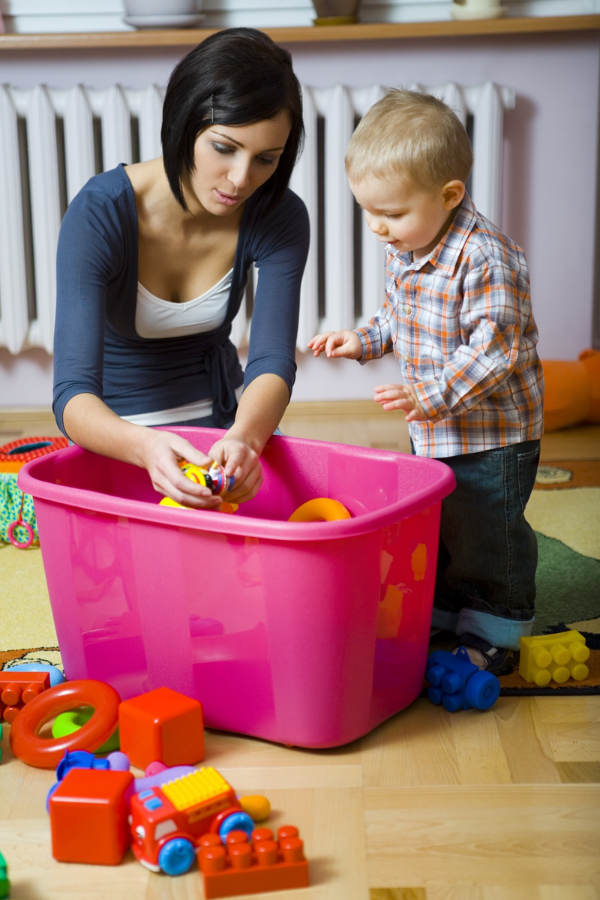

**Talk to Me**

**Tidying away**

Encourage your child to join in.

Talk about what you are doing and how they can help.

Have handy containers for different toys and show your child how you can sort them out, but don’t worry if things get mixed up! Make it fun.

Give your child lots of praise and encouragement.