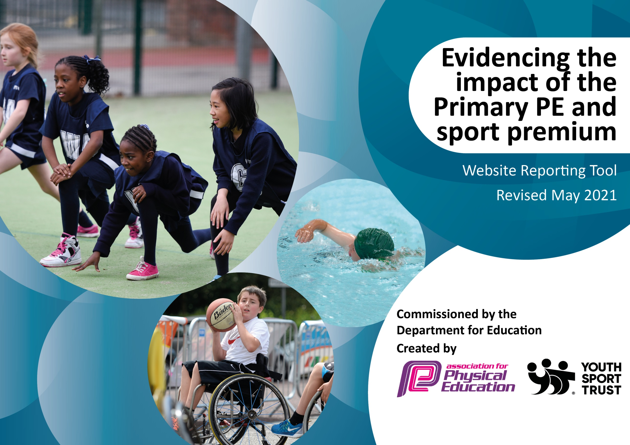

It is important that your grant is used effectively and based on school need. The Education Inspection Framework (Ofsted 2019 p64) makes clear there will be a focus on ‘whether leaders and those responsible for governors all understand their respective roles and perform these in a way that enhances the effectiveness of the school’.

Under the Quality of Education criteria (p41) inspectors consider the extent to which schools can articulate their curriculum (INTENT), construct their curriculum (IMPLEMENTATION) and demonstrate the outcomes which result (IMPACT).

To assist schools with common transferable language this template has been developed to utilise the same three headings which should make your plans easily transferable between working documents.

Schools must use the funding to make additional and sustainable improvements to the quality of Physical Education, School Sport and Physical Activity (PESSPA) they offer. This means that you should use the Primary PE and sport premium to:

- Develop or add to the PESSPA activities that your school already offer
- Build capacity and capability within the school to ensure that improvements made now will benefit pupils joining the school in future years
- The Primary PE and sport premium should not be used to fund capital spend projects; the school’s budget should fund these.
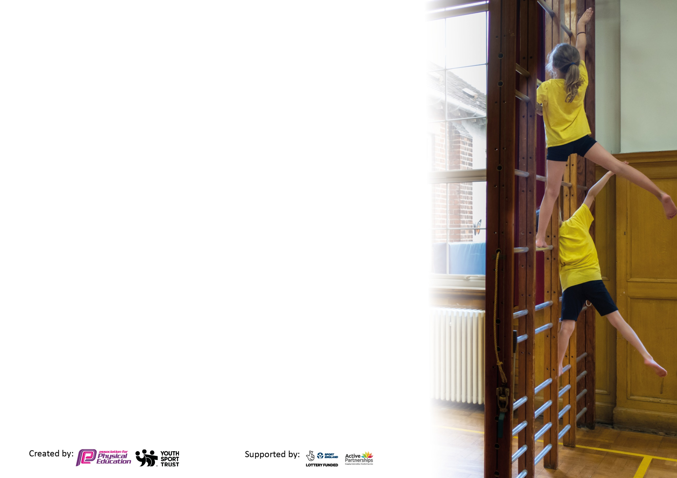
Please visit gov.uk for the revised DfE guidance including the 5 key indicators across which schools should demonstrate an improvement. This document will help you to review your provision and to report your spend. DfE encourages schools to use this template as an effective way of meeting the reporting requirements of the Primary PE and sport premium.

We recommend you start by reflecting on the impact of current provision and reviewing the previous spend.

Schools are required to publish details of how they spend this funding, including any under-spend from 2019/2020, as well as on the impact it has on pupils’ PE and sport participation and attainment by the end of the summer term or by 31st July 2021 at the latest.

We recommend regularly updating the table and publishing it on your website throughout the year. This evidences your ongoing self-evaluation of how you are using the funding to secure maximum, sustainable impact. Final copy must be posted on your website by the end of the academic year and no later than the 31st July 2021. To see an example of how to complete the table please click HERE.

Please note: Although there has been considerable disruption in 2020 it is important that you publish details on your website of how you spend the funding - this is a legal requirement.
Support for review and reflection - considering the 5 key indicators from DfE, what development needs are a priority for your setting and your pupils now and why? Use the space below to reflect on previous spend and key achievements and areas for development.

N.B. In this section you should refer to any adjustments you might have made due to Covid-19 and how these will influence further improvement.
Key achievements to date until July 2020: | Areas for further improvement and baseline evidence of need:
CPD through INSET, Twilights, courses and specialist coaches for staff in different areas of PE – Dance, Games and Gymnastics.  High quality resources for children to use.  Children more active during lunchtimes and playtimes  Children more active during lessons – active maths lessons taught through maths of the day.  All children taking part in intra school competitions throughout the school year.  Increase in number of children taking part in inter school competitions and festivals (Cross country, infant agility, dance and gymnastics festivals) Pre covid.  Daily active activity – The Daily Mile, Cosmic Yoga.  Children have had opportunities to experience different sports and create local club links - All Stars Cricket, Creswell Tennis Club, Laura Anns School of Dance Club. | Encourage more children to attend afterschool clubs. - Increase the number for Pupil premium pupils attending after school clubs and being active during lunch time sessions.  Implement the new Real PE scheme of work and focus on implementing the assessment tool.  Develop leadership roles with children – mini leaders to work with and support younger members of the school once it is safe to do so.  Embed physical activities into the daily timetable by looking for more active ways to teach lessons.

Did you carry forward an underspend from 2019-20 academic year into the current academic year? YES/NO
Total amount carried forward from 2019/2020 £4349
+ Total amount for this academic year 2020/2021 £17,440
= Total to be spent by 31st July 2021 £21,789

Meeting national curriculum requirements for swimming and water safety.  N.B Complete this section to your best ability. For example you might have practised safe self-rescue techniques on dry land which you can transfer to the pool when school swimming restarts.  Due to exceptional circumstances priority should be given to ensuring that pupils can perform safe self rescue even  if they do not fully meet the first two requirements of the NC programme of study. | N/A
What percentage of your current Year 6 cohort swim competently, confidently and proficiently over a distance of at least 25 metres?  N.B. Even though your pupils may swim in another year please report on their attainment on leaving primary school at the end of the summer term 2021.  Please see note above. | N/A
What percentage of your current Year 6 cohort use a range of strokes effectively [for example, front crawl, backstroke and breaststroke]?  Please see note above. | N/A
What percentage of your current Year 6 cohort perform safe self-rescue in different water-based situations? | N/A
Schools can choose to use the Primary PE and sport premium to provide additional provision for swimming but this must be for activity over and above the national curriculum requirements. Have you used it in this way? | Yes/No N/A

Action Plan and Budget Tracking
Capture your intended annual spend against the 5 key indicators. Clarify the success criteria and evidence of impact that you intend to measure to evaluate for pupils today and for the future.

Academic Year: 2020/21 | Total fund allocated: £17440 | Date Updated: 02/07/2021
Key indicator 1: The engagement of all pupils in regular physical activity – Chief Medical Officers guidelines recommend that primary school pupils undertake at least 30 minutes of physical activity a day in school |  |  |  | Percentage of total allocation:
 |  |  |  | %
Intent | Implementation |  | Impact
Your school focus should be clear what you want the pupils to know and be able to do and about  what they need to learn and to  consolidate through practice: | Make sure your actions to achieve are linked to your intentions: | Funding allocated: | Evidence of impact: what do pupils now know and what can they now do? What has changed?: | Sustainability and suggested next steps:
Give the children a rich cross-curricular approach to P.E that will set them up and prepare them, for their future life.  Ensure this approach also incorporates a mindfulness approach that looks at social and emotional health.  All pupils to make progress in each lesson/unit/year.  Development of their fundamental skills and movement to help develop fine and gross motor skills.  Children to have the opportunity to try a range of different sports and become more active. Children will be able to develop new skills and have links to local sport clubs.  To ensure that children are physically active and engage in at least 30 minutes physical activity a day. | Real P.E  P.E and social and emotional health course for the P.E lead.  PE resource audit and new PE equipment bought providing a range of good quality PE equipment.  Fundamental interventions  - Bolsover interventions and after school clubs  Promote and encourage children to take part in after school clubs and local sports clubs by promoting it on class Dojo and leaflets.  Stationary sports equipment for the playground so this can be accessed at lunch and break times. | £294  £125  Resources  £640  £900  £25  £11,210 | PE equipment audit – staff to have the correct and enough equipment to teach a broad and balanced curriculum.  PE lead to upskill all staff so that that they have a good understanding of social and emotional health.  Real PE assessment tool to show progress.  Evidence shown in PE lessons and in children’s writing, teacher feedback and learning walks.  Evidence shown in after school club registers. More children are taking part in after school clubs.  Parents are aware of these clubs from letters, text messages and class dojo messages.  To continue to develop their gross motor skills independently at break times. | All children will access two hours of high quality PE, using high quality equipment.  PE lead to do a staff meeting on social and emotional health in P.E and to support staff in lessons.  To ensure all staff are confident in using the Real PE assessment tool.  Fine motor and gross motor activities are embedded throughout the school in a cross curricular approach.  Next step - Develop more active lunch and play times.  To continue to improve the playground and ensure high quality equipment is accessible to all.
Key indicator 2: The profile of PESSPA being raised across the school as a tool for whole school improvement |  |  |  | Percentage of total allocation:
 |  |  |  | %
Intent | Implementation |  | Impact
Your school focus should be clear what you want the pupils to know and be able to do and about  what they need to learn and to  consolidate through practice: | Make sure your actions to achieve are linked to your intentions: | Funding allocated: | Evidence of impact: what do pupils now know and what can they now do? What has changed?: | Sustainability and suggested next steps:
Make sure children are engaged in physical activities at break and lunch time.  PE and sport achievements are mentioned in class/celebration assemblies to ensure the whole school are aware of how important it is. This will also encourage other less active pupils to become involved in order to be mentioned in assemblies.  Children will develop their leadership skills.  Children to stay active as much as they can throughout the school day. | New high quality PE equipment.  Assemblies to celebrate our achievements.  We will train the year 2’s to become mini leaders for foundation and year 1 during lunch times.  Whole school approach to the daily mile.  Cosmic yoga  Continue to subscribe to maths of the day and class teachers to implement this at least once a week. | Equipment as Above.  Maths of the day subscription  £575 | Children are active and enjoy sport. This gives them a positive mind set for sport and will hopefully encourage them to continue sport throughout life.  P.E display board in the hall – That shows children’s achievements to give them a sense of pride.  The display board also shows Real PE objectives so children know how to challenge themselves and become interested in their learning.  The children have opportunities to be leaders and to organise games and events. They have a pupil’s voice and listen to what their peers want.  Children will be active more throughout the day. I will know this through lesson observations and from staff and pupil feedback | To promote sporting achievements in golden time assemblies from September rather than just in class because of the Covid bubbles.  Continue to develop lunchtime activities.  Continue to develop more active lessons through a cross curricular approach and through high quality teaching.

Key indicator 3: Increased confidence, knowledge and skills of all staff in teaching PE and sport |  |  |  | Percentage of total allocation:
 |  |  |  | %
Intent | Implementation |  | Impact
Your school focus should be clear | Make sure your actions to | Funding | Evidence of impact: what do | Sustainability and suggested
what you want the pupils to know | achieve are linked to your | allocated: | pupils now know and what | next steps:
and be able to do and about | intentions: |  | can they now do? What has
what they need to learn and to |  |  | changed?:
consolidate through practice:
Continue to develop the teacher’s skills and knowledge of a range of sports. This will give the children high quality PE lessons.  Develop skills and knowledge of all staff when planning and assessing PE lessons. | Book specialist P.E coaches to work alongside staff and train and upskill them in different areas of P.E.  This is done through Real PE and supported by the PE lead. Staff have all been trained in twilight sessions for this. | Specialist sports teacher part of Bolsover SSP £3000  Dance with Laura Ann - £2210  Cricket - £350  Real PE Subscription (as above) | Staff feel confident teaching and assessing PE. They know the progression of skills throughout FS and KS1. They teach the children the skills to be able to challenge themselves as well as having the support and guidance from the teacher. Staff teach the children to practise but they also allow the children to make their own mistakes and learn from these. | Staff will continue to use Real PE to keep their knowledge ongoing and to ensure the progression of skills is consistent throughout school.  Next Steps -  To continue to develop and assess staffs weaknesses and strengths in P.E  To audit staff to identify their weaknesses and to give them support in this area.
Key indicator 4: Broader experience of a range of sports and activities offered to all pupils |  |  |  | Percentage of total allocation:
 |  |  |  | %
Intent | Implementation |  | Impact
Your school focus should be clear | Make sure your actions to | Funding | Evidence of impact: what do | Sustainability and suggested
what you want the pupils to know | achieve are linked to your | allocated: | pupils now know and what | next steps:
and be able to do and about | intentions: |  | can they now do? What has
what they need to learn and to |  |  | changed?:
consolidate through practice:
Additional achievements:  To ensure a range of sports and activities are offered to all pupils through festivals and competitions.  Children will have the opportunities to try new sports in after school clubs. | Affiliate to SSP to access a broad range of festivals. Take children to a range of festivals and competitions. A different variety of sports to be done in school from SSP due to Covid.  Assembly and newsletters to promote after school clubs and sporting events.  Arrange and book a range of different sporting after school clubs.  Promote after school clubs and encourage children to attend them through class dojo, assemblies and newsletters. | £2460  After school clubs as above. | The children will have the opportunities to compete against other children from other schools and learn a range of skills – Festival/competition registers.  Club registers – The children will have the opportunities to experience a range of sporting activities afterschool. | Next steps – To increase pupils attending competitions and festivals.  Next steps – To continue to develop a range of after school clubs to increase uptake in the clubs.  Continue to develop local club links.  Introduce – Orienteering and boccia/ soft archery into the school timetable.

Key indicator 5: Increased participation in competitive sport |  |  |  | Percentage of total allocation:
 |  |  |  | %
Intent | Implementation |  | Impact
Your school focus should be clear | Make sure your actions to | Funding | Evidence of impact: what do | Sustainability and suggested
what you want the pupils to know | achieve are linked to your | allocated: | pupils now know and what | next steps:
and be able to do and about | intentions: |  | can they now do? What has
what they need to learn and to |  |  | changed?:
consolidate through practice:
Children will be able to develop skills in competitive sports.  Children are motivated, engaged physically, and are motivated during play and lunchtimes.  Children to support each other in working together to progress and improve their PE skills. They can work well together and can help each other to improve their Physical skills.  Children will enjoy the success and enjoy being part of a team.  Children have the opportunities to compete against different schools and within school. | Ensure that competitive sports and competitions are planned into the school calendar.  Plan and organise a sports week.  Plan a team building competitive day.  Train year 2 children to be mini leaders.  Book a variety of sporting after school clubs.  Take children to a range of P.E festivals and cross country events.  Work with Midday staff to plan lunchtime events.  P.E Lead to attend meetings within the cluster and school sports, to organise events with locals school and to organise events to be brought into to our own school to give the children access to different sports and to compete. | Infant package –  As above (£2460) | Meetings with Midday staff to plan and organise lunchtime events.  Meetings with play leaders to train and plan – this will develop children’s leadership skills.  Registers/photographs – The children are given the opportunities to compete against other children from a range of schools in the cluster and within school. These are great experiences. | All children to take part in intra activities and competitions and events.  Continue to plan activities to develop children’s teambuilding skills. – SSP.  Continue to increase the number of pupils taking part in inter school competitions.  Next Steps – Begin to embed weekly challenges, both personal and class challenges into the timetable.

Signed off by
Head Teacher: | A Dodd
Date: | 05/07/2021
Subject Leader: | B Woods
Date: | 02/07/21
Governor: | S Wilmot
Date: | 12/07/21

