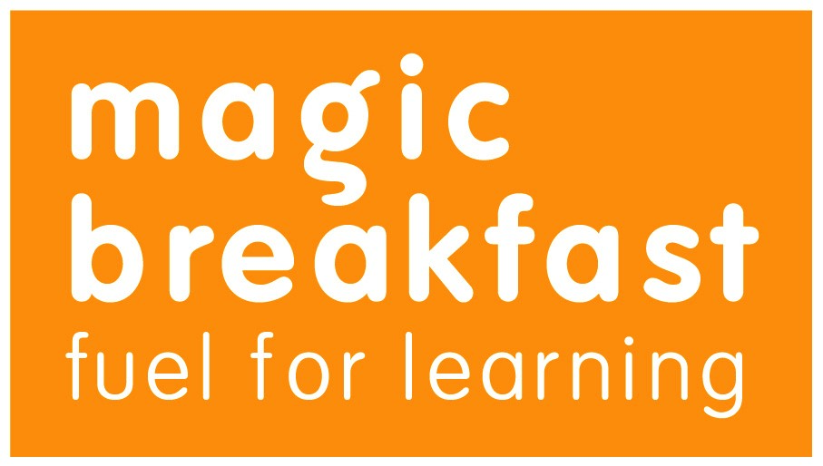
Magic Breakfast Food and Drink Ingredients and Allergens List
Magic Breakfast is committed to providing healthy, balanced and safe food and drink for our Magic Breakfast clubs.
Due to the increase in awareness and diagnosis of people with allergies, it is essential that we have all the relevant information on the composition of our food and drink.
Below is a list of the ingredients, allergens and advisory information relating to all Magic Breakfast food. We will regularly update this document with any changes so please familiarise yourself with the information provided.
Please also note that we receive a variety of different juices from Tropicana and Copella therefore it is imperative that you check the label if you are worried about the presence of a particular allergen in our juices.
Magic Breakfast Food products
Bagels – Bagel Nash
Ingredients for Magic Plain Bagel: Wheat Flour, Water, Wholemeal flour, Sugar, Salt, Yeast and Malt
Allergens: Wheat flour (gluten), Wholemeal flour (gluten)
Advisory note: Made in a factory which uses milk products, contains wheat gluten and yeast and contain sesame seeds
Porridge Oats - Quaker Oats
Ingredients: 100% Quaker Rolled Oats
Allergens: None
Advisory note: May contain traces of wheat and barley due to farming practices (gluten)
Cereals - Tesco
Tesco Rice Snaps
Ingredients: Rice, Sugar, Salt, Barley Malt Extract, Iron, Niacin, Pantothenic Acid, Riboflavin, Vitamin B6, Thiamin, Folic Acid, Vitamin D, Vitamin B12
Allergens: Barley (gluten)
Advisory note: None
Tesco Corn Flakes
Ingredients: Maize, Sugar, Salt, Dextrose, Barley Malt Extract, Iron, Niacin, Pantothenic Acid, Vitamin B6, Riboflavin, Thiamin, Folic Acid, Vitamin D, Vitamin B12
Allergens: Barley (gluten)
Advisory note: None
Tesco Wheat Biscuits
Ingredients: Wheat (95%), Malted Barley Extract, Sugar, Salt, Niacin, Iron, Riboflavin, Thiamin, Folic Acid
Allergens: Wheat (gluten), Barley (gluten)
Advisory note: None
Tesco Malt Wheats
Ingredients: Wholewheat (92%), Sugar, Malted Barley Extract, Partially Inverted Sugar Syrup, Salt, Niacin, Iron, Pantothenic Acid, Thiamin, Riboflavin, Vitamin B6, Folic Acid, Vitamin B12
Allergens: Wholewheat (gluten), Barley (gluten)
Advisory note: May contain nuts (produced in a factory where nuts are handled for other products).
Juice – Tropicana and Copella
Ingredients: 100% pure and natural juices
Allergens: None
Advisory note: please check the ingredients list for specific ingredients that you may be allergic to.

