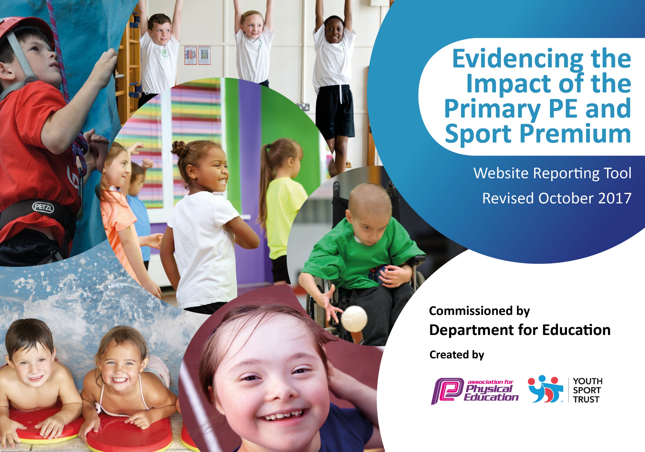

Schools must use the funding to make additional and sustainable improvements to the quality of PE and sport they offer. This means that you should use the Primary PE and Sport Premium to:

- develop or add to the PE and sport activities that your school already offers
- build capacity and capability within the school to ensure that improvements made now will benefit pupils joining the school in future years

Please visit gov.uk for the revised DfE guidance including the 5 key indicators across which schools should demonstrate an improvement. This document will help you to review your provision and to report your spend. DfE encourages schools to use this template as an effective way of meeting the reporting requirements of the Primary PE and Sport Premium.

We recommend you start by reflecting on the impact of current provision and reviewing the previous spend.
Under the Ofsted Schools Inspection Framework, inspectors will assess how effectively leaders use
the Primary PE and Sport Premium and measure its impact on outcomes for pupils, and how effectively governors hold them to account
for this.

Schools are required to publish details of how they spend this funding as well as on the impact it has on pupils’ PE
and sport participation and attainment.
We recommend regularly updating the table and
publishing it on your website as evidence
of your ongoing review into how you are using the money
to secure maximum, sustainable impact. To see an example of how to complete the table please click HERE.

Support for review and reflection - considering the 5 key indicators from DfE, what development needs are a priority for your setting and your students now and why? Use the space below to reflect on previous spend, identify current need and priorities for the future.

Key achievements to date: | Areas for further improvement and baseline evidence of need:  - To continue to support staff with their CPD and improve their skills and confidence in delivering excellent P.E lessons.  - To research and implement a whole school assessment tool that shows progression clearly from EYFS right through to the end of KS1.  - Link PE to mental health and emotional wellbeing for the whole school.  - Recruitment of a play leader to improve activities during playtimes.
- Cross Country. 1st Boys and 2nd Girls Cluster competition.
- Encouraging less active children to take part in classes including Wheelchair basketball and afterschool clubs for Football, Basketball & Dance.
- Participating in Inclusive competitions around the Cluster.
- A whole school approach to Active Maths.
- Using the Daily mile throughout KS1 and FS2.To encourage a whole school approach to getting children active.
- Implementing mini leaders at breaks and lunch times.

Meeting national curriculum requirements for swimming and water safety | Please complete all of the below:
What percentage of your Year 6 pupils could swim competently, confidently and proficiently over a distance of at least 25 metres when they left your primary school at the end of last academic year? | %  Not applicable.
What percentage of your Year 6 pupils could use a range of strokes effectively [for example, front crawl, backstroke and breaststroke] when they left your primary school at the end of last academic year? | %  Not applicable.
What percentage of your Year 6 pupils could perform safe self-rescue in different water-based situations when they left your primary school at the end of last academic year? | %  Not applicable.
Schools can choose to use the Primary PE and Sport Premium to provide additional provision for swimming but this must be for activity over and above the national curriculum requirements. Have you used it in this way? | Yes/No  Not applicable.

Action Plan and Budget Tracking
Capture your intended annual spend against the 5 key indicators. Clarify the success criteria and evidence of impact that you intend to measure to evaluate for students today and for the future.

Academic Year: 2018/19  . | Total fund allocated: £16,000 plus £10 per pupil April to April.  £17,206 | Date Updated: 11th Feb 2019
Key indicator 1: The engagement of all pupils in regular physical activity – Chief Medical Officer guidelines recommend that primary school children undertake at least 30 minutes of physical activity a day in school |  |  |  | Percentage of total allocation:
 |  |  |  | 46%
School focus with clarity on intended impact on pupils: | Actions to achieve: | Funding allocated: | Evidence and impact: | Sustainability and suggested next steps:
- Increase the number of children taking part in sporting activities through identifying less active children and inviting them to join the after school basketball, tennis, dance, football or ball skills club (PE Coordinator to monitor)  - Provide opportunities available to all children to engage with sport either before or after school.  - Ensure all children can take part in daily physical activity. | - Provide a range of free and paid for sporting clubs, after school and before school (including breakfast club).  - Produce letters to make parents aware of clubs, and display a timetable of the clubs available.  - Daily Mile, Curriculum PE, Lunchtime sports, After School Clubs. | £3535  £50  Contribution to Staffing costs  £4,314. Other costs included in  club costs. | - Registers to show increased engagement. The pupils have greater access to a range of all sports.  - Registers to show high take up for Sports Clubs.  - Teacher observations to show impact on their wellbeing as this will improve their behaviour because they will be engaged in meaningful activities. | - Induction for new staff, Teaching and non-teaching, on expectations of delivery of daily physical activity.
Key indicator 2: The profile of PE and sport being raised across the school as a tool for whole school improvement |  |  |  | Percentage of total allocation:
 |  |  |  | 1%
School focus with clarity on intended impact on pupils: | Actions to achieve: | Funding allocated: | Evidence and impact: | Sustainability and suggested next steps:
- School Improvement Plan clearly states our school aims including:  - to promote physical development through high quality PE and an extensive range of after school activities. | - Different sports to be on offer in order to appeal to different ages and abilities. e.g Basketball, tennis, dance  - Purchase of an activity board in the playground to advertise these sports and to also encourage and promote competitions. | £100 | - This will be monitored by weekly checks by the subject coordinator.  - Being active has an impact on being ready to learn. E.g. research from trialing the daily mile has shown that after exercise children are much more alert and they produce better work. This is also reflected in other subjects such as Maths.  - Maintaining this research through teacher observations and pupils surveys | - As above and ensure that the quality of sport being delivered throughout school is being monitored.

Key indicator 3: Increased confidence, knowledge and skills of all staff in teaching PE and sport |  |  |  | Percentage of total allocation:
 |  |  |  | 35%
School focus with clarity on intended  impact on pupils: | Actions to achieve: | Funding  allocated: | Evidence and impact: | Sustainability and suggested  next steps:
- Work with the school sports partnership to allow children the opportunities to take part in a range of different competitions and sporting events.  - Ensure Pupil premium children are targeted to ensure they are taking part in physical activity.  - PE coordinator to have release time in order to monitor planning, teaching and participation and to ensure that new initiatives are being met. PE coordinator to attend courses and to ensure new staff have the opportunity to attend these courses.  - Develop children’s dance and fundamental skills in all ages throughout the school so that they can transfer these skills into all areas of Sport and be fully prepared for competitions.  - Ensure high standards of PE are consistently available and are in line with the new curriculum by doing an audit.  - Give staff the opportunity to learn from and work alongside specialist PE coaches to enhance learning for all children.  - Provide CPD courses for staff , including new staff members where it is possible. | - CPD for staff from skilled providers modelling and coaching.  - Affiliate to SSP to access a broad range of festivals and competitions within the school cluster.  - Basketball coach.  - Wheelchair basketball day.  - Dance and skilled fundamentals teacher  - Coaching  Monitoring (Learning Walks)  - Move with a Zip course and resources  - Year 1 Fundamentals course | SSP money included against Key 5.  £500  £300  £5041  £100  £150 | - Weekly coaching and team teaching impacts on staff knowledge of dance and fundamentals.  - Staff feel confident to deliver Fundamentals to classes and groups.  - Ipad evidence and teacher observations show the improvements in learning in young children accessing dance and fundamentals lessons  - This will be mirrored in P.E planning and will show that a wide range of skills are being taught throughout the curriculum.  - Children will develop P.E skills that they will be able to transfer throughout life.  - Write up of monitoring presented to governors.  Observations of PE. | - Working with sports providers to continue CPD with new staff structure.  - Ensure the children are accessing a different range of sports both in and after school.
Key indicator 4: Broader experience of a range of sports and activities offered to all pupils |  |  |  | Percentage of total allocation:
 |  |  |  | 1%
School focus with clarity on intended  impact on pupils: | Actions to achieve: | Funding  allocated: | Evidence and impact: | Sustainability and suggested  next steps:
- Organise and set up ‘zoned’ areas at lunchtime including an area dedicated to a specific ‘sport’ each half term to promote enjoyable sporting activities and develop skills at lunchtime and play times. Provide areas to improve core skills and balance. | - Identified mini leaders within year groups. Trained by class teacher to encourage leadership & organizational skills through play.  - To purchase a wide variety of sports games and equipment to encourage every child to take part in an active 30:30. Such as Connect 4 game board, skittles, Boccia, bowls etc. | £150 | - Mini leaders are encouraging more inactive children to take part in sports at playtime and lunch time.  - Equipment purchased to improve physical engagement at playtime and lunch time. | - To ensure the children have access to a wide range of activities in play time and to monitor this regularly by planning with the class teacher and spending time outside at play times.  - Purchase of new games.
Key indicator 5: Increased participation in competitive sport |  |  |  | Percentage of total allocation:
 |  |  |  | 17%
School focus with clarity on intended  impact on pupils: | Actions to achieve: | Funding  allocated: | Evidence and impact: | Sustainability and suggested  next steps:
- Develop team work and sporting values by ensuring children have the opportunity to attend regular competitions and festivals. | Attendance at Inclusion Festivals. | £1956  SSP money  £1010  Transport | - Registers to show attendance in festivals and competitions.  - Photos will be taken when children attend competitions and letters to parents will be kept in the P.E folder as evidence.  - It develops lifelong skills and as the children have to work in teams in sport, this is transferable throughout the rest of the curriculum when it comes to working in groups. | - Ensure children are competing in the competitions around the cluster. Allocate year groups to attend the different festivals offered to us.

