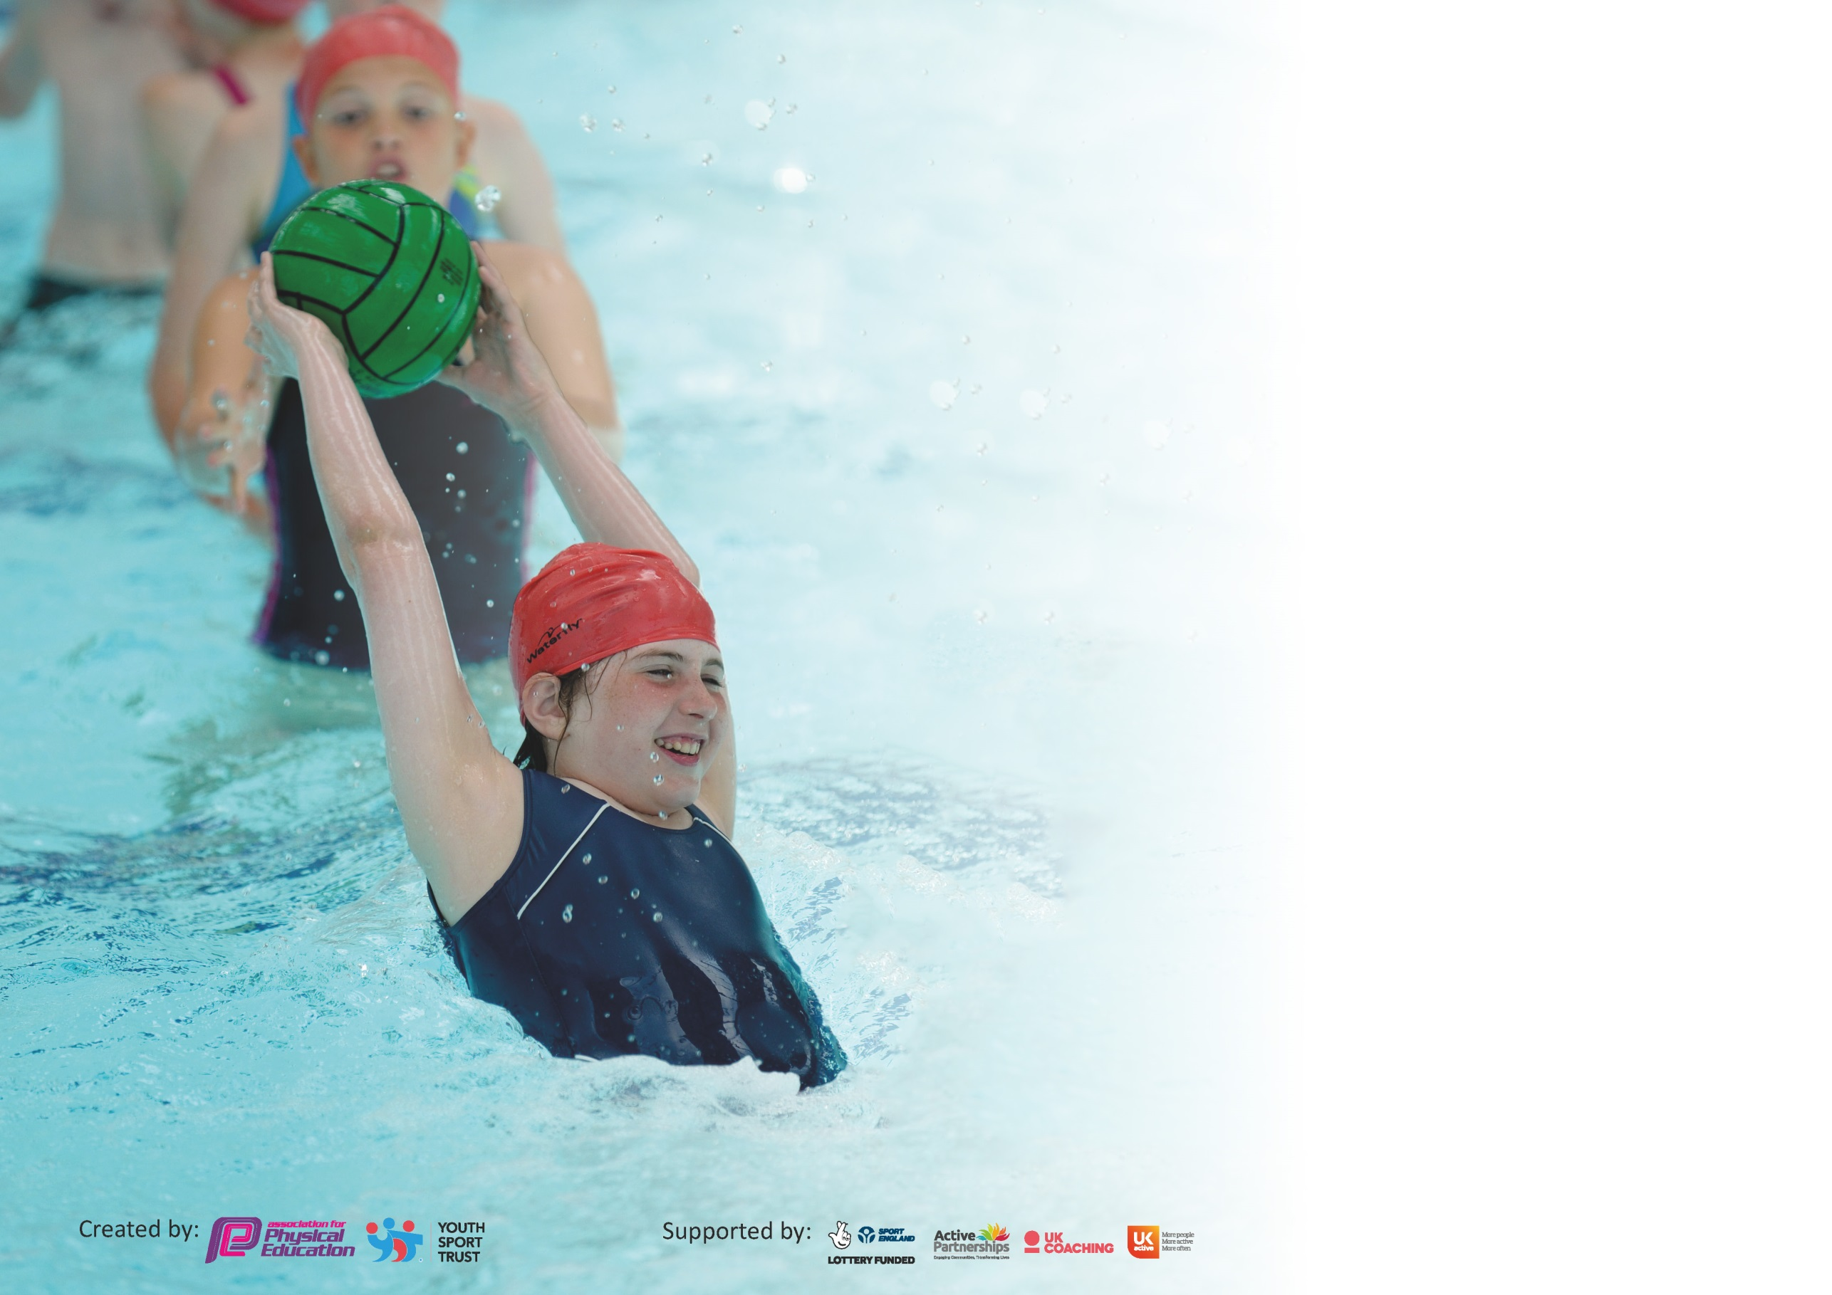

It is important that your grant is used effectively and based on school need. The Education Inspection Framework (Ofsted 2019 p64) makes clear there will be a focus on ‘whether leaders and those responsible for governors all understand their respective roles and perform these in a way that enhances the effectiveness of the school’.

Under the Quality of Education criteria (p41) inspectors consider the extent to which schools can articulate their curriculum (INTENT), construct their curriculum (IMPLEMENTATION) and demonstrate the outcomes which result (IMPACT).

To assist schools with common transferable language this template has been developed to utilise the same three headings which should make your plans easily transferable between working documents.

Schools must use the funding to make additional and sustainable improvements to the quality of Physical Education, School Sport and Physical Activity (PESSPA) they offer. This means that you should
use the Primary PE and Sport Premium to:

- Develop or add to the PESSPA activities that your school already offer
- Build capacity and capability within the school to ensure that improvements made now will benefit pupils joining the school in future years

Please visit gov.uk for the revised DfE guidance including the 5 key indicators across which schools should demonstrate an improvement. This document will help you to review your provision and to report your spend. DfE encourages schools to use this template as an effective way of meeting the reporting requirements of the Primary PE and Sport Premium.

We recommend you start by reflecting on the impact of current provision and reviewing the previous spend.

Schools are required to publish details of how they spend this funding as well as on the impact it has on pupils’ PE and sport participation and attainment by the end of the summer term or by 31st July 2020 at the latest.

We recommend regularly updating the table and publishing it on your website throughout the year. This evidences your ongoing self-evaluation of how you are using the funding to secure maximum, sustainable impact. Final copy must be posted on your website by the end of the academic year and no later than the 31st July 2020. To see an example of how to complete the table please click HERE.

Support for review and reflection - considering the 5 key indicators from DfE, what development needs are a priority for your setting and your pupils now and why? Use the space below to reflect on previous spend and key achievements and areas for development.

Key achievements to date until July 2019: | Areas for further improvement and baseline evidence of need:
- Encouraging less active children to take part in classes including Wheelchair basketball and afterschool clubs for Football, Basketball & Dance.  - Participating in Inclusive competitions around the Cluster.  - A whole school approach to Active Maths.  - Using the Daily mile throughout KS1.To encourage a whole school approach to getting children active. | - Implementing mini leaders at breaks and lunch times.  - Real P.E implemented throughout school to show a clear progression of skills (This now needs to be continued in order the show the full Impact as it was implemented just before Lockdown).  - Continue to Link PE to mental health and emotional wellbeing for the whole school.

Meeting national curriculum requirements for swimming and water safety.
What percentage of your current Year 6 cohort swim competently, confidently and proficiently over a distance of at least 25 metres?  N.B. Even though your pupils may swim in another year please report on their attainment on leaving  primary school at the end of the summer term 2020. | N/A
What percentage of your current Year 6 cohort use a range of strokes effectively [for example, front crawl, backstroke and breaststroke]? | N/A
What percentage of your current Year 6 cohort perform safe self-rescue in different water-based situations? | N/A
Schools can choose to use the Primary PE and Sport Premium to provide additional provision for swimming but this must be for activity over and above the national curriculum requirements. Have you used it in this way? | N/A

Action Plan and Budget Tracking
Capture your intended annual spend against the 5 key indicators. Clarify the success criteria and evidence of impact that you intend to measure to evaluate for pupils today and for the future.

Academic Year: 2019/2020 | Total fund allocated: £16,000 plus £10 per pupil April to April.  £17,206 | Date Updated: 06/07/2020
Key indicator 1: The engagement of all pupils in regular physical activity – Chief Medical Officer guidelines recommend that primary school pupils undertake at least 30 minutes of physical activity a day in school |  |  |  | Percentage of total allocation:
 |  |  |  | 46%
Intent | Implementation |  | Impact
- (Ongoing) Increase the number of children taking part in sporting activities through identifying less active children and inviting them to join the after school basketball, tennis, dance, football or ball skills club (PE Coordinator to monitor)  - Continue to Provide opportunities available to all children to engage with sport either before or after school.  - Ensure all children can take part in daily physical activity through the Daily mile/Real P.E/ Cosmic Yoga/Mini leader games.  - Ensure that the children have a rich cross curricular approach to P.E that will set them up and prepare them for future life. | - Provide a range of free and paid for sporting clubs, after school and before school (including breakfast club -when possible – due to Coronavirus)  - Produce letters to make parents aware of clubs, and display a timetable of the clubs available.  - Daily Mile, Curriculum PE, Lunchtime sports, After School Clubs.  - The Implementation of Real P.E | Funding allocated:  £3535  £50  Contribution to Staffing costs  £2,714. Other costs included in  club costs  £1600 | - Registers to show increased engagement. The pupils have greater access to a range of all sports.  - Registers to show high take up for Sports Clubs.  - Registers to show increased engagement. The pupils have greater access to a range of all sports.  Teacher observations to show impact on their wellbeing as this will improve their behaviour because they will be engaged in meaningful activities.Teacher observations to show impact on their wellbeing as this will improve their behaviour because they will be engaged in meaningful activities.  Real P.E will also show next steps for all chilren | Induction for new staff, Teaching and non-teaching, on expectations of delivery of daily physical activity.
Key indicator 2: The profile of PESSPA being raised across the school as a tool for whole school improvement |  |  |  | Percentage of total allocation:
 |  |  |  | 1%
Intent | Implementation |  | Impact
- School Improvement Plan clearly states our school aims including:  - to promote physical development through high quality PE and an extensive range of after school activities. | - Different sports to be on offer in order to appeal to different ages and abilities. e.g Basketball, tennis, dance  - Purchase of an activity board in the playground to advertise these sports and to also encourage and promote competitions. | £100 | - This will be monitored by termly by the subject coordinator.  - Being active has an impact on being ready to learn. E.g. research from trialing the daily mile has shown that after exercise children are much more alert and they produce better work. This is also reflected in other subjects such as Maths.  - Maintaining this research through teacher observations and pupils surveys. | As above and ensure that the quality of sport being delivered throughout school is being monitored

Key indicator 3: Increased confidence, knowledge and skills of all staff in teaching PE and sport |  |  |  | Percentage of total allocation:
 |  |  |  | 35%
Intent | Implementation |  | Impact
- Work with the school sports partnership to allow children the opportunities to take part in a range of different competitions and sporting events.  - Ensure Pupil premium children are targeted to ensure they are taking part in physical activity.  - PE coordinator to have release time in order to monitor planning, teaching and participation and to ensure that new initiatives are being met. PE coordinator to attend courses and to ensure new staff have the opportunity to attend these courses.  - Develop children’s dance and fundamental skills in all ages throughout the school so that they can transfer these skills into all areas of Sport and be fully prepared for competitions.  - Ensure high standards of PE are consistently available and are in line with the new curriculum by doing an audit.  - Give staff the opportunity to learn from and work alongside specialist PE coaches to enhance learning for all children.  - Provide CPD courses for staff , including new staff members where it is possible. | - CPD for staff from skilled providers modelling and coaching.  - Affiliate to SSP to access a broad range of festivals and competitions within the school cluster.  - Basketball coach.  - Wheelchair basketball day.  - Dance and skilled fundamentals teacher  - Coaching  Monitoring (Learning Walks)  - Move with a Zip course and resources  - Whole school Real P.E. training | SSP money included against Key 5.  £500  £300  £5041  £100  £150 | - Weekly coaching and team teaching impacts on staff knowledge of dance and fundamentals.  - Staff feel confident to deliver Fundamentals to classes and groups.  - Ipad evidence and teacher observations show the improvements in learning in young children accessing dance and fundamentals lessons  - This will be mirrored in P.E planning and will show that a wide range of skills are being taught throughout the curriculum.  - Children will develop P.E skills that they will be able to transfer throughout life.  - Write up of monitoring presented to governors.  Observations of PE. | - Working with sports providers to continue CPD with new staff structure.  - Ensure the children are accessing a different range of sports both in and after school.
Key indicator 4: Broader experience of a range of sports and activities offered to all pupils |  |  |  | Percentage of total allocation:
 |  |  |  | 1%
Intent | Implementation |  | Impact
Organise and set up ‘zoned’ areas at lunchtime including an area dedicated to a specific ‘sport’ each half term to promote enjoyable sporting activities and develop skills at lunchtime and play times. Provide areas to improve core skills and balance. | - Identified mini leaders within year groups. Trained by class teacher to encourage leadership & organizational skills through play.  - To purchase a wide variety of sports games and equipment to encourage every child to take part in an active 30:30. Such as Connect 4 game board, skittles, Boccia, bowls etc. | £150 | - Mini leaders are encouraging more inactive children to take part in sports at playtime and lunch time.  - Equipment purchased to improve physical engagement at playtime and lunch time. | - To ensure the children have access to a wide range of activities in play time and to monitor this regularly by planning with the class teacher and spending time outside at play times.  - Purchase of new games.
Additional achievements:

Key indicator 5: Increased participation in competitive sport |  |  |  | Percentage of total allocation:
 |  |  |  | 17%
Intent | Implementation |  | Impact
- Develop team work and sporting values by ensuring children have the opportunity to attend regular competitions and festivals. | Attendance at Inclusion Festivals. | £1956  SSP money  £1010  Transport | - Registers to show attendance in festivals and competitions.  - Photos will be taken when children attend competitions and letters to parents will be kept in the P.E folder as evidence.  - It develops lifelong skills and as the children have to work in teams in sport, this is transferable throughout the rest of the curriculum when it comes to working in groups. | - Ensure children are competing in the competitions around the cluster. Allocate year groups to attend the different festivals offered to us.

Signed off by
Head Teacher: | A Dodd
Date: | 06/07/2020
Subject Leader: | R Woods
Date: | 06/07/2020
Governor: | C Senogles
Date: | 06/07/2020

